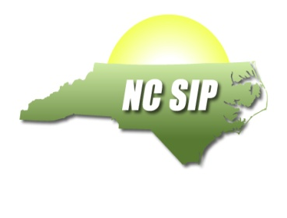
Institution of Higher Education Partner

IHE: ___UNC Charlotte________

 | Name | Address | Email | Phone
NCSIP Coordinator (Name and Title) | Belva Collins, Chair, Department of Special Education and Child Development | 9201 University City Blvd.  UNC Charlotte  Charlotte, NC 28223 | 704-687-8186 | 704-687-8186
Established Reading/Math Foundations Trainer(s) | Coming soon
Donna Sacco | Assistant Professor,  Special Education | 9201 University City Blvd.  UNC Charlotte  Charlotte, NC 28223 | dsacco1@uncc.edu | 704-687-8829
John Beattie | Assistant Professor, Special Education  Adjunct | 9201 University City Blvd.  UNC Charlotte  Charlotte, NC 28223 | jrbeattie@uncc.edu
NCSIP DPI Liaison | Teri Queen |  | Teri.Queen@dpi.nc.gov | 828-803-1488

NCSIP Program Information

Brief description of SIP activities | - Department of Special Education & Child Development personnel trained in Reading and Math Foundations evidence-based practice  - Initial licensure candidates at the undergraduate and graduate levels enroll in modified courses  - Student Teaching/ Graduate Internship placements in classrooms with Foundations prepared cooperating teachers  - Dual Licensure Program (Special Education/ Elementary Education) Professional Learning Community develops strategies for Foundations content instruction  - Reading and Elementary Education Department personnel trained in Reading and Math Foundations evidence-based practice  - Regional training opportunities in Reading and Math Foundations evidence-based practices offered to general and special education teachers in the region
NC SIP LEA Partners | Potential Partners:  Cabarrus County Schools  Lincoln County Schools  Stanly County Schools  Cleveland County Schools  Union County Schools  Gaston County Schools  Charlotte-Mecklenburg Schools  Rowan County Schools  Iredell Statesville County Schools  Kannopolis City Schools

